**Countdown to Kindergarten: Tips to Ensure Your Child is Ready**

Kindergarten is coming up fast, and we know you want your child to feel confident and ready for this exciting next step. To help, we spoke with Jodi Schreck, the Executive Vice President of our Education Team. With 35 years of experience in early childhood education, K-12, special education, and education leadership, she’s the perfect person to give us some kindergarten readiness tips.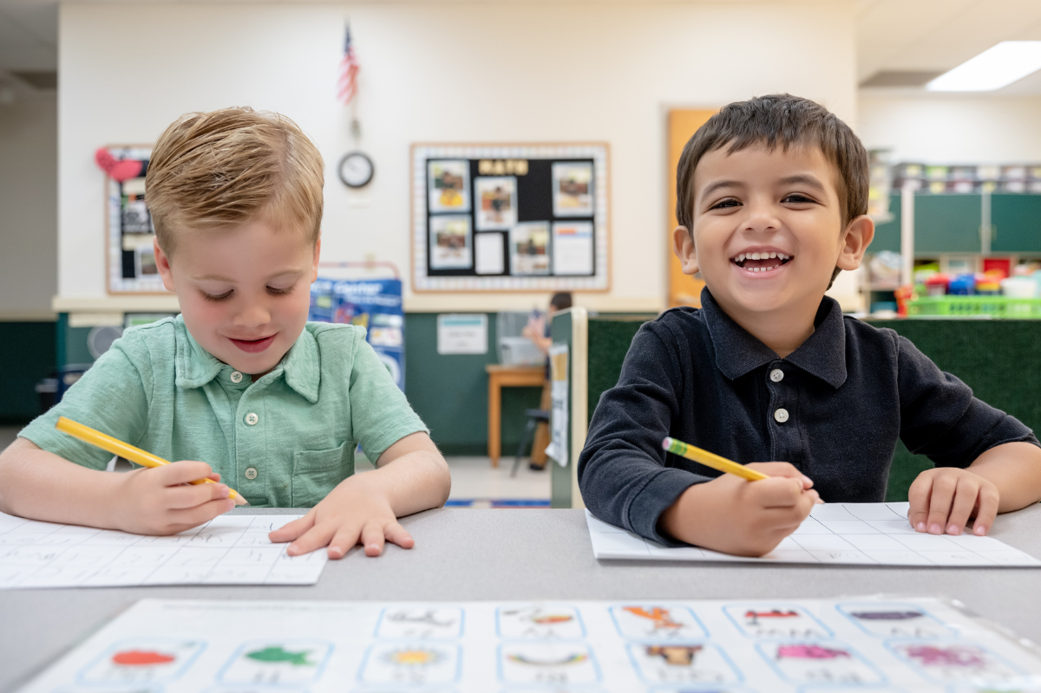

## **Hi, Jodi! What are some academic skills families can help their child develop to prepare for kindergarten?**

Great question! First, help your child work on basic skills like counting, recognizing shapes, and knowing their letters and sounds. You can use everyday items like toys or snacks to practice shapes, colors, and counting. Reading together is one of the best ways to boost literacy. Ask questions during and after the story to help your child understand it better, and let them ask you questions too. Singing the alphabet is a fun way to practice sequencing letters, and make sure your child can write their name. Don’t forget fine motor skills—teach your child how to hold a pencil and scissors correctly.

## **Do social skills play a role in kindergarten success?**

Absolutely! Social skills are huge when it comes to kindergarten readiness. How your child interacts with others will influence classroom success. Encourage skills like sharing, taking turns, following directions, and expressing feelings in healthy ways. Role-playing can be a great tool for teaching emotional awareness, like helping your child label their feelings or understand how others are feeling, especially if there is a conflict. Reading books together or just talking about everyday situations helps too. Playdates and group activities give your child a chance to practice these skills in real life.

## **This is all great advice. What are some other kindergarten preparation tips you can share with us?**

* Encourage independence – Have your child start doing things like dressing themselves and taking care of their belongings. It’s a great confidence booster!
* Teach your child how to put things away correctly and stay organized.
* Play games like ‘Simon Says’ or ‘Red Light, Green Light.’ They’re great for practicing following directions and staying focused.
* Practice conversation skills – teach your child how to listen, ask questions, and take turns when speaking.
* Set up a daily routine with regular wake-up times, meals, and bedtimes to help your child adjust to the school day’s structure.

Adding these to your kindergarten readiness checklist will make sure your child is building important skills while still having fun!

## **Thanks, Jodi! Any final thoughts?**

I have to say that preschool is an awesome way to help your child get ready for kindergarten. It introduces them to classroom routines, gives them a chance to interact with other kids, and teaches early literacy concepts. These experiences will make the transition to kindergarten much smoother and can ease any worries your child might have about starting school.