**How to Create Learning Spaces at Home**

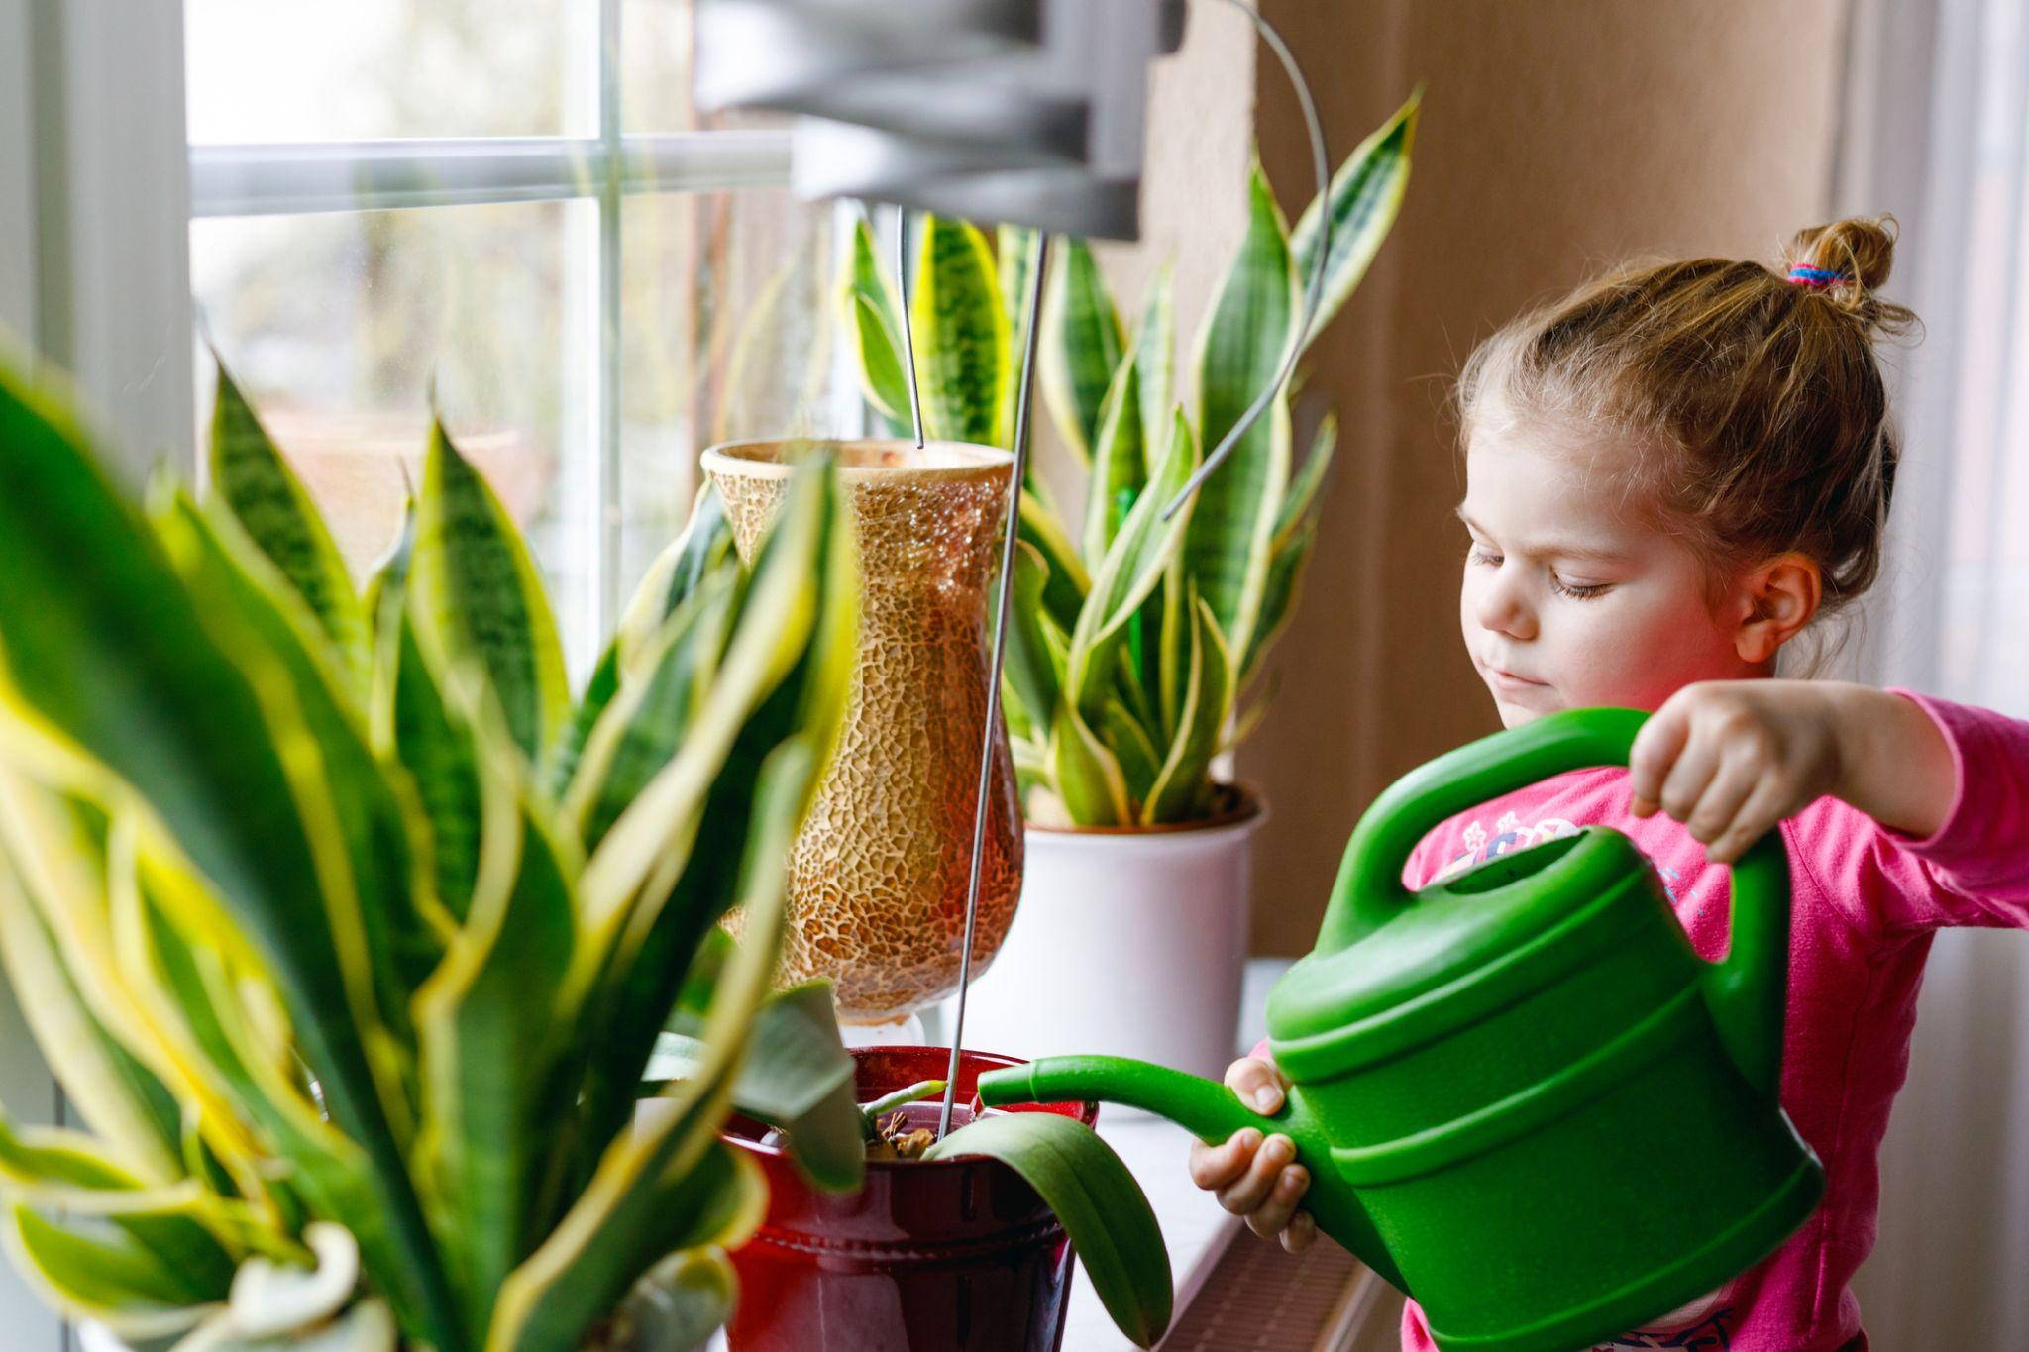

Creating an inviting and supportive home learning environment is important for your child’s development. A well-designed space helps children explore, be creative, and learn on their own. Here are some tips for how to best create learning spaces at home from Dena Christensen, a member of our Education Team. Dena joined our team in 2003 as an ECE Principal. She has over 30 years of experience working with children and is now the Manager of Educational Services for Early Childhood Education. Dena stays current on the latest research to bring new ideas and best practices to our school.

**Hi Dena! How would you define a learning space, and can you share some tips for creating them at home?**

Sure! A learning space is a place in your home that encourages exploration and learning. It should be easy for your child to access and have a clear purpose. Here are some ideas:

Create a **reading nook** for kids in your child’s room. Make it cozy with pillows, a comfy floor cushion, a soft rug, and blankets. Add good lighting and easy-to-reach books. This space helps build literacy skills and sparks imagination.

Set up an **art station**. This can be a table in the kitchen or living room with materials like paper, crayons, markers, glue sticks, and collage items to encourage creativity. Avoid using coloring books or workbooks to give your child more room for self-expression. This space can also be used to practice writing by providing writing utensils, paper or journals, and visual text.

Consider creating a **sensory play area**. Fill it with playdough, squishy toys, and materials with different textures. This space helps your child explore through touch, sparks creativity, and can provide a calming effect when emotions run high. You can also add visual aids like feelings cards to help them identify and name their emotions, promoting emotional literacy and self-awareness.

Set up a small **play kitchen** in your kitchen. Children learn a lot from watching adults. Give your child measuring spoons, cups, large bowls, and cookbooks. As they measure and pour along with you, they will practice math skills, like counting and volume.

Create a **nature corner** or **garden center** as part of your home learning environment. Choose a sunny spot in your house or yard to fill with plants, rocks, and natural objects to encourage curiosity and a love for nature. Involve your child in caring for the plants. An herb garden or strawberry plant is an easy way to start. This hands-on experience teaches about plant care and the importance of nurturing living things.

**Are there any rules for designing these spaces?**

Yes! Place quieter activities in calm rooms, like bedrooms, and noisier activities in livelier spaces, such as the kitchen. It’s hard to focus on art or a book with a TV on in the background! Make sure the space is comfortable and child-friendly with age-appropriate materials and child-sized furniture to promote independence. Keep things organized and labeled so your child can easily find and return items.

**Do you have any other tips?**

Keep things simple and clean. A neat space is more inviting. Use neutral colors to create a calm feeling. Choose places with plenty of natural light to help your child focus. While it’s great to have a reading nook in the bedroom, I also suggest placing books throughout the house. Also, rotating toys, books, and writing materials keeps things engaging and fresh for your child.