**5 Books to Read With Children in Honor of Black History Month**

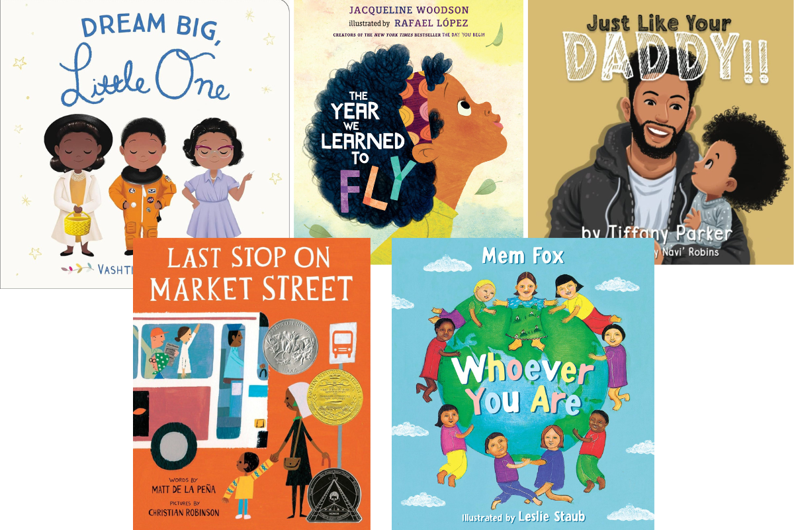

Black History Month is a time to celebrate Black Americans and their important role in U.S. history. In our schools, children learn about Black culture and heritage through books, activities, and discussions. While we talk about and celebrate diversity all year, February is a special time to honor Black history and learn more about its significance.

Here are five great books for children about Black history and celebrating what makes us unique and special. They are sure to inspire, teach, and engage.

***Dream Big, Little One* by Vashti Harrison (ages 1+)**

This book introduces young readers to Black women who changed the world. It encourages children to dream big like Mae Jemison, be brave like Maya Angelou, and be creative like Alma Woodsey Thomas. It is a perfect bedtime story to inspire big dreams!

***Whoever You Are* by Mem Fox (ages 2+)**

This story celebrates the many kinds of children and ways of life all over the world. Readers will learn that, though others may look, speak, and live differently, they all share the same feelings and experiences. They will discover that we all are a lot alike.

***Just Like Your Daddy* by Tiffany Parker (ages 3+)**

This expressive story is filled with an abundance of affirmations that are meant to uplift and empower children. It also shines a bright light on fathers and depicts the strong and special relationship between a Black father and son.

***Last Stop on Market Street* by** [**Matt de la Peña**](https://www.amazon.com/Matt-de-la-Pe%25C3%25B1a/e/B001IXRRQI?ref=sr_ntt_srch_lnk_1&qid=1736368957&sr=8-1) **and** [**Christian Robinson**](https://www.amazon.com/Christian-Robinson/e/B00H4AT6SG?ref=sr_ntt_srch_lnk_1&qid=1736368957&sr=8-1) **(ages 3+)**

In this heartwarming story, a young boy and his grandmother take a bus ride through their neighborhood. On their journey, they encounter all sorts of people and opportunities to look on the bright side. The book teaches how to see the beauty in everyday life and reminds us to appreciate every person.

***The Year We Learned to Fly* by Jacqueline Woodson (ages 4+)**

*The Year We Learned to Fly* is about a brother and sister who face challenges. When they feel stuck, their grandmother teaches them to use their imagination to "fly" and escape. Children will learn how creativity can help them through challenging times and how the wisdom of older generations can guide them.